Jungle Adventure with Admob

Please follow the steps to get ready your game.

1. **Import source in eclipse:**

Open eclipse, go to File/Import and select your project.  
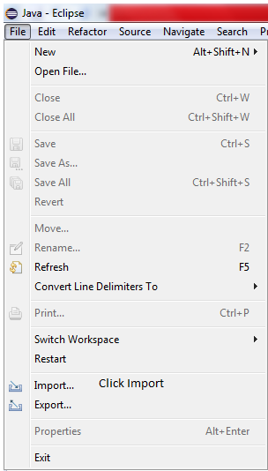

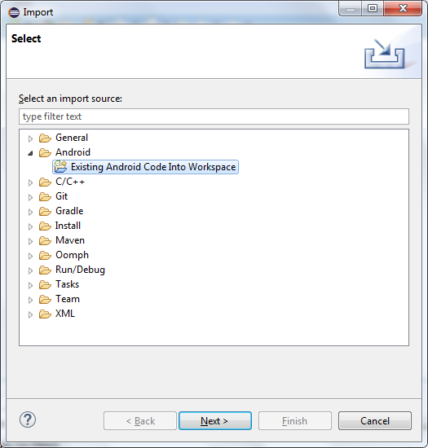

Select your project and google play service lib.  
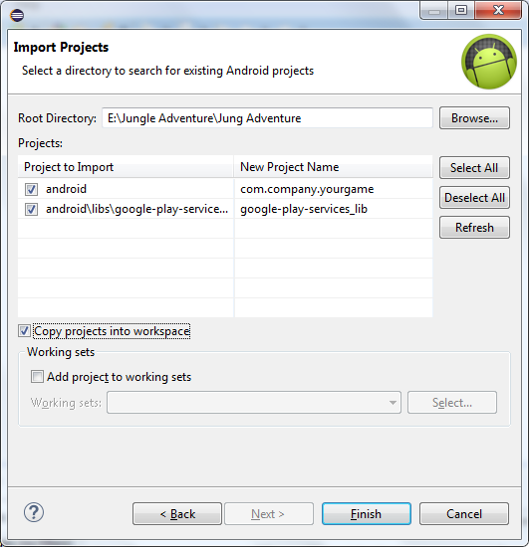

Fix Lib problem if you see it.  
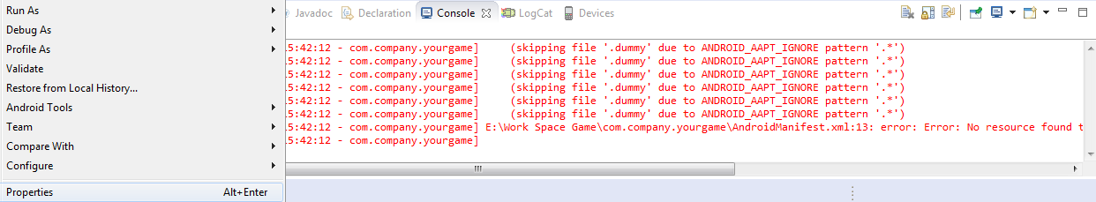

Choose properties.  
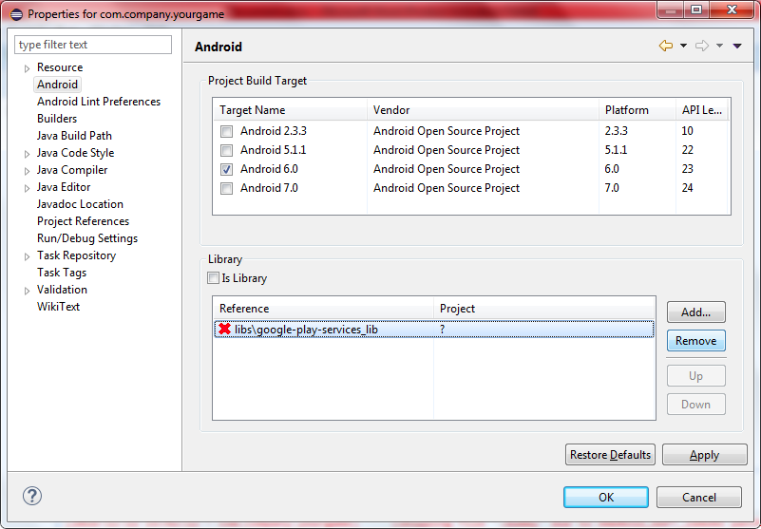

Remove wrong path lib and add the new lib.

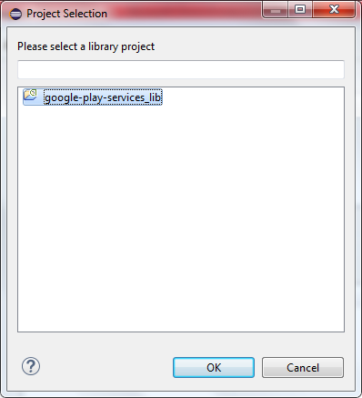

1. **Change package name:**

Change Package ID to be unique, Version, and Version Name to be suitable your App development.  
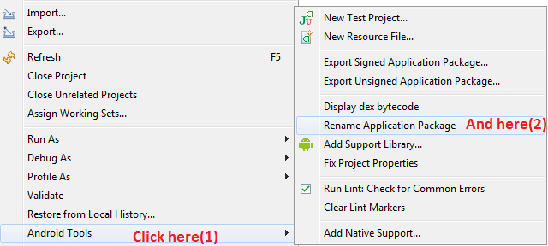

Enter new package name:

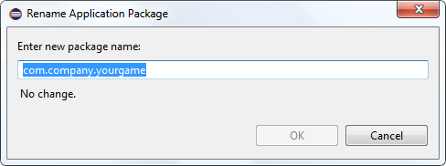

And finish:  
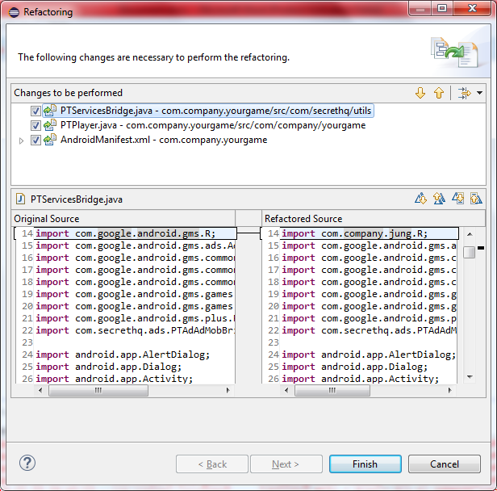

1. **Change asset, sound:**

|  |  |  |  |
| --- | --- | --- | --- |
| N | Need to change | The Path | Notes |
| 1 | Game icons | Assets/icon.png | Change all icons images |
| 2 | Launch screen | Assets/default.png | Change it for your image |
| 3 | Game assets | Assets/data/atlases | All images used in your game need to change |
| 4 | Game Sounds | Assets/data/ sounds | Change it for your sounds |

1. **Change admob ID, share message…**

|  |  |  |  |
| --- | --- | --- | --- |
| Number | Need to change | The Path | Notes |
| 1 | Review Link | <key>reviewLink</key> <string>ID_HERE</string> | Change it to your Link. |
| 2 | Leaderboard Id | <key>leaderboardId</key> <string>ID_HERE</string> | Change it to your ID. |
| 3 | adMob Banner | key>adMobBanner</key> <string>ID_HERE</string> | Change it to your ID. |
| 4 | adMob Interstitial | <key>adMobInterstitial</key> <string>ID_HERE</string> | Change it to your ID. |
| 5 | Share Message | <key>adMobInterstitial</key> <string>Message</string> | Change it to your messag |

**Thanks for purchasing this item!  
We hope you liked the game.  
Don’t forget rate the item from downloads page : click here  
Good luck!**